阿良技术博客：https://blog.51cto.com/lizhenliang/2325770

官方提供的几种Kubernetes部署方式
- minikube
Minikube是一个工具，可以在本地快速运行一个单点的Kubernetes，尝试Kubernetes或日常开发的用户使用。不能用于生产环境。
官方地址：https://kubernetes.io/docs/setup/minikube/
- kubeadm
Kubeadm也是一个工具，提供kubeadm init和kubeadm join，用于快速部署Kubernetes集群。
官方地址：https://kubernetes.io/docs/reference/setup-tools/kubeadm/kubeadm/
- 二进制包
从官方下载发行版的二进制包，手动部署每个组件，组成Kubernetes集群。
小结：
生产环境中部署Kubernetes集群，只有Kubeadm和二进制包可选，Kubeadm降低部署门槛，但屏蔽了很多细节，遇到问题很难排查。我们这里使用二进制包部署Kubernetes集群，我也是推荐大家使用这种方式，虽然手动部署麻烦点，但学习很多工作原理，更有利于后期维护。

软件环境
软件 | 版本
操作系统 | CentOS7.5_x64
Docker | 18-ce
Kubernetes | 1.12

服务器角色
角色 | IP | 组件
k8s-master | 192.168.31.63 | kube-apiserver，kube-controller-manager，kube-scheduler，etcd
k8s-node1 | 192.168.31.65 | kubelet，kube-proxy，docker，flannel，etcd
k8s-node2 | 192.168.31.66 | kubelet，kube-proxy，docker，flannel，etcd
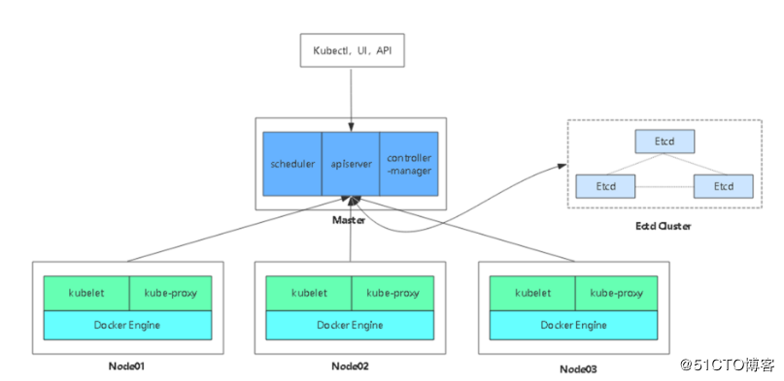
​ 架构图

1. 部署Etcd集群
使用cfssl来生成自签证书，先下载cfssl工具：
wget https://pkg.cfssl.org/R1.2/cfssl_linux-amd64
wget https://pkg.cfssl.org/R1.2/cfssljson_linux-amd64
wget https://pkg.cfssl.org/R1.2/cfssl-certinfo_linux-amd64
chmod +x cfssl_linux-amd64 cfssljson_linux-amd64 cfssl-certinfo_linux-amd64
mv cfssl_linux-amd64 /usr/local/bin/cfssl
mv cfssljson_linux-amd64 /usr/local/bin/cfssljson
mv cfssl-certinfo_linux-amd64 /usr/bin/cfssl-certinfo

1.1 生成证书
创建以下三个文件：
# cat ca-config.json
{
"signing": {
"default": {
"expiry": "87600h"
},
"profiles": {
"www": {
"expiry": "87600h",
"usages": [
"signing",
"key encipherment",
"server auth",
"client auth"
]
}
}
}
}

# cat ca-csr.json
{
"CN": "etcd CA",
"key": {
"algo": "rsa",
"size": 2048
},
"names": [
{
"C": "CN",
"L": "Beijing",
"ST": "Beijing"
}
]
}

# cat server-csr.json
{
"CN": "etcd",
"hosts": [
"192.168.31.63",
"192.168.31.65",
"192.168.31.66"
],
"key": {
"algo": "rsa",
"size": 2048
},
"names": [
{
"C": "CN",
"L": "BeiJing",
"ST": "BeiJing"
}
]
}
生成证书：
cfssl gencert -initca ca-csr.json | cfssljson -bare ca -
cfssl gencert -ca=ca.pem -ca-key=ca-key.pem -config=ca-config.json -profile=www server-csr.json | cfssljson -bare server
# ls *pem
ca-key.pem ca.pem server-key.pem server.pem
证书这块知道怎么生成、怎么用即可，建议暂时不必过多研究。

1.2 部署Etcd
二进制包下载地址：https://github.com/coreos/etcd/releases/tag/v3.2.12
以下部署步骤在规划的三个etcd节点操作一样，唯一不同的是etcd配置文件中的服务器IP要写当前的：
解压二进制包：
# mkdir /opt/etcd/{bin,cfg,ssl} -p
# tar zxvf etcd-v3.2.12-linux-amd64.tar.gz
# mv etcd-v3.2.12-linux-amd64/{etcd,etcdctl} /opt/etcd/bin/
创建etcd配置文件：
# cat /opt/etcd/cfg/etcd
#[Member]
ETCD_NAME="etcd01"
ETCD_DATA_DIR="/var/lib/etcd/default.etcd"
ETCD_LISTEN_PEER_URLS="https://192.168.31.63:2380"
ETCD_LISTEN_CLIENT_URLS="https://192.168.31.63:2379"

#[Clustering]
ETCD_INITIAL_ADVERTISE_PEER_URLS="https://192.168.31.63:2380"
ETCD_ADVERTISE_CLIENT_URLS="https://192.168.31.63:2379"
ETCD_INITIAL_CLUSTER="etcd01=https://192.168.31.63:2380,etcd02=https://192.168.31.65:2380,etcd03=https://192.168.31.66:2380"
ETCD_INITIAL_CLUSTER_TOKEN="etcd-cluster"
ETCD_INITIAL_CLUSTER_STATE="new"
- ETCD_NAME 节点名称
- ETCD_DATA_DIR 数据目录
- ETCD_LISTEN_PEER_URLS 集群通信监听地址
- ETCD_LISTEN_CLIENT_URLS 客户端访问监听地址
- ETCD_INITIAL_ADVERTISE_PEER_URLS 集群通告地址
- ETCD_ADVERTISE_CLIENT_URLS 客户端通告地址
- ETCD_INITIAL_CLUSTER 集群节点地址
- ETCD_INITIAL_CLUSTER_TOKEN 集群Token
- ETCD_INITIAL_CLUSTER_STATE 加入集群的当前状态，new是新集群，existing表示加入已有集群
systemd管理etcd：
# cat /usr/lib/systemd/system/etcd.service
[Unit]
Description=Etcd Server
After=network.target
After=network-online.target
Wants=network-online.target

[Service]
Type=notify
EnvironmentFile=/opt/etcd/cfg/etcd
ExecStart=/opt/etcd/bin/etcd \
--name=${ETCD_NAME} \
--data-dir=${ETCD_DATA_DIR} \
--listen-peer-urls=${ETCD_LISTEN_PEER_URLS} \
--listen-client-urls=${ETCD_LISTEN_CLIENT_URLS},http://127.0.0.1:2379 \
--advertise-client-urls=${ETCD_ADVERTISE_CLIENT_URLS} \
--initial-advertise-peer-urls=${ETCD_INITIAL_ADVERTISE_PEER_URLS} \
--initial-cluster=${ETCD_INITIAL_CLUSTER} \
--initial-cluster-token=${ETCD_INITIAL_CLUSTER_TOKEN} \
--initial-cluster-state=new \
--cert-file=/opt/etcd/ssl/server.pem \
--key-file=/opt/etcd/ssl/server-key.pem \
--peer-cert-file=/opt/etcd/ssl/server.pem \
--peer-key-file=/opt/etcd/ssl/server-key.pem \
--trusted-ca-file=/opt/etcd/ssl/ca.pem \
--peer-trusted-ca-file=/opt/etcd/ssl/ca.pem
Restart=on-failure
LimitNOFILE=65536

[Install]
WantedBy=multi-user.target
把刚才生成的证书拷贝到配置文件中的位置：
# cp ca*pem server*pem /opt/etcd/ssl
启动并设置开启启动：
# systemctl start etcd
# systemctl enable etcd
都部署完成后，检查etcd集群状态：
# /opt/etcd/bin/etcdctl \
--ca-file=ca.pem --cert-file=server.pem --key-file=server-key.pem \
--endpoints="https://192.168.31.63:2379,https://192.168.31.65:2379,https://192.168.31.66:2379" \
cluster-health
member 18218cfabd4e0dea is healthy: got healthy result from https://192.168.31.63:2379
member 541c1c40994c939b is healthy: got healthy result from https://192.168.31.65:2379
member a342ea2798d20705 is healthy: got healthy result from https://192.168.31.66:2379
cluster is healthy
如果输出上面信息，就说明集群部署成功。如果有问题第一步先看日志：/var/log/message 或 journalctl -u etcd

2. 在Node安装Docker
# yum install -y yum-utils device-mapper-persistent-data lvm2
# yum-config-manager \
--add-repo \
https://download.docker.com/linux/centos/docker-ce.repo
# yum install docker-ce -y
# curl -sSL https://get.daocloud.io/daotools/set_mirror.sh | sh -s http://bc437cce.m.daocloud.io
# systemctl start docker
# systemctl enable docker

3. 部署Flannel网络
工作原理：
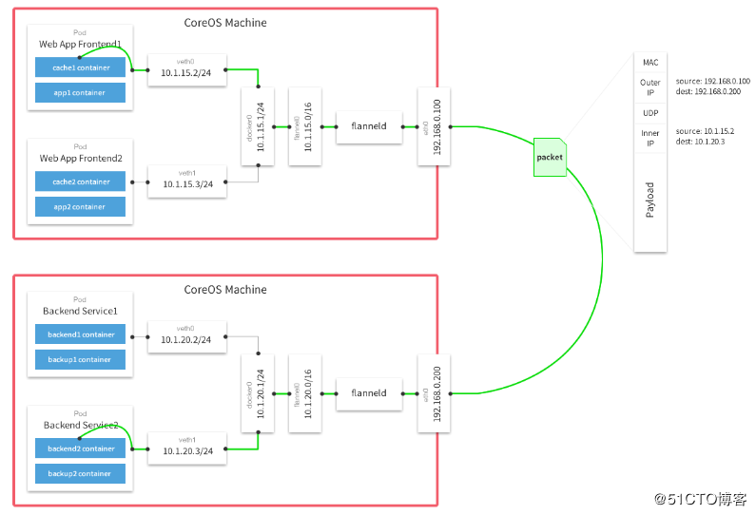
Falnnel要用etcd存储自身一个子网信息，所以要保证能成功连接Etcd，写入预定义子网段：
# /opt/etcd/bin/etcdctl \
--ca-file=ca.pem --cert-file=server.pem --key-file=server-key.pem \
--endpoints="https://192.168.31.63:2379,https://192.168.31.65:2379,https://192.168.31.66:2379" \
set /coreos.com/network/config '{ "Network": "172.17.0.0/16", "Backend": {"Type": "vxlan"}}'
以下部署步骤在规划的每个node节点都操作。
下载二进制包：
# wget https://github.com/coreos/flannel/releases/download/v0.10.0/flannel-v0.10.0-linux-amd64.tar.gz
# tar zxvf flannel-v0.9.1-linux-amd64.tar.gz
# mv flanneld mk-docker-opts.sh /opt/kubernetes/bin
配置Flannel：
# cat /opt/kubernetes/cfg/flanneld
FLANNEL_OPTIONS="--etcd-endpoints=https://192.168.31.63:2379,https://192.168.31.65:2379,https://192.168.31.66:2379 -etcd-cafile=/opt/etcd/ssl/ca.pem -etcd-certfile=/opt/etcd/ssl/server.pem -etcd-keyfile=/opt/etcd/ssl/server-key.pem"
systemd管理Flannel：
# cat /usr/lib/systemd/system/flanneld.service
[Unit]
Description=Flanneld overlay address etcd agent
After=network-online.target network.target
Before=docker.service

[Service]
Type=notify
EnvironmentFile=/opt/kubernetes/cfg/flanneld
ExecStart=/opt/kubernetes/bin/flanneld --ip-masq $FLANNEL_OPTIONS
ExecStartPost=/opt/kubernetes/bin/mk-docker-opts.sh -k DOCKER_NETWORK_OPTIONS -d /run/flannel/subnet.env
Restart=on-failure

[Install]
WantedBy=multi-user.target
配置Docker启动指定子网段：
# cat /usr/lib/systemd/system/docker.service

[Unit]
Description=Docker Application Container Engine
Documentation=https://docs.docker.com
After=network-online.target firewalld.service
Wants=network-online.target

[Service]
Type=notify
EnvironmentFile=/run/flannel/subnet.env
ExecStart=/usr/bin/dockerd $DOCKER_NETWORK_OPTIONS
ExecReload=/bin/kill -s HUP $MAINPID
LimitNOFILE=infinity
LimitNPROC=infinity
LimitCORE=infinity
TimeoutStartSec=0
Delegate=yes
KillMode=process
Restart=on-failure
StartLimitBurst=3
StartLimitInterval=60s

[Install]
WantedBy=multi-user.target
重启flannel和docker：
# systemctl daemon-reload
# systemctl start flanneld
# systemctl enable flanneld
# systemctl restart docker
检查是否生效：
# ps -ef |grep docker
root 20941 1 1 Jun28 ? 09:15:34 /usr/bin/dockerd --bip=172.17.34.1/24 --ip-masq=false --mtu=1450
# ip addr
3607: flannel.1: <BROADCAST,MULTICAST,UP,LOWER_UP> mtu 1450 qdisc noqueue state UNKNOWN
link/ether 8a:2e:3d:09:dd:82 brd ff:ff:ff:ff:ff:ff
inet 172.17.34.0/32 scope global flannel.1
valid_lft forever preferred_lft forever
3608: docker0: <BROADCAST,MULTICAST,UP,LOWER_UP> mtu 1450 qdisc noqueue state UP
link/ether 02:42:31:8f:d3:02 brd ff:ff:ff:ff:ff:ff
inet 172.17.34.1/24 brd 172.17.34.255 scope global docker0
valid_lft forever preferred_lft forever
inet6 fe80::42:31ff:fe8f:d302/64 scope link
valid_lft forever preferred_lft forever
确保docker0与flannel.1在同一网段。
测试不同节点互通，在当前节点访问另一个Node节点docker0 IP：
# ping 172.17.58.1
PING 172.17.58.1 (172.17.58.1) 56(84) bytes of data.
64 bytes from 172.17.58.1: icmp_seq=1 ttl=64 time=0.263 ms
64 bytes from 172.17.58.1: icmp_seq=2 ttl=64 time=0.204 ms
如果能通说明Flannel部署成功。如果不通检查下日志：journalctl -u flannel

4. 在Master节点部署组件
在部署Kubernetes之前一定要确保etcd、flannel、docker是正常工作的，否则先解决问题再继续。

4.1 生成证书
创建CA证书：
# cat ca-config.json
{
"signing": {
"default": {
"expiry": "87600h"
},
"profiles": {
"kubernetes": {
"expiry": "87600h",
"usages": [
"signing",
"key encipherment",
"server auth",
"client auth"
]
}
}
}
}

# cat ca-csr.json
{
"CN": "kubernetes",
"key": {
"algo": "rsa",
"size": 2048
},
"names": [
{
"C": "CN",
"L": "Beijing",
"ST": "Beijing",
"O": "k8s",
"OU": "System"
}
]
}

# cfssl gencert -initca ca-csr.json | cfssljson -bare ca -
生成apiserver证书：
# cat server-csr.json
{
"CN": "kubernetes",
"hosts": [
"10.0.0.1",
"127.0.0.1",
"192.168.31.63",
"kubernetes",
"kubernetes.default",
"kubernetes.default.svc",
"kubernetes.default.svc.cluster",
"kubernetes.default.svc.cluster.local"
],
"key": {
"algo": "rsa",
"size": 2048
},
"names": [
{
"C": "CN",
"L": "BeiJing",
"ST": "BeiJing",
"O": "k8s",
"OU": "System"
}
]
}
cfssl gencert -ca=ca.pem -ca-key=ca-key.pem -config=ca-config.json -profile=kubernetes server-csr.json | cfssljson -bare server
生成kube-proxy证书：
# cat kube-proxy-csr.json
{
"CN": "system:kube-proxy",
"hosts": [],
"key": {
"algo": "rsa",
"size": 2048
},
"names": [
{
"C": "CN",
"L": "BeiJing",
"ST": "BeiJing",
"O": "k8s",
"OU": "System"
}
]
}

# cfssl gencert -ca=ca.pem -ca-key=ca-key.pem -config=ca-config.json -profile=kubernetes kube-proxy-csr.json | cfssljson -bare kube-proxy
最终生成以下证书文件：
# ls *pem
ca-key.pem ca.pem kube-proxy-key.pem kube-proxy.pem server-key.pem server.pem

4.2 部署apiserver组件
下载二进制包：https://github.com/kubernetes/kubernetes/blob/master/CHANGELOG-1.12.md
下载这个包（kubernetes-server-linux-amd64.tar.gz）就够了，包含了所需的所有组件。
# mkdir /opt/kubernetes/{bin,cfg,ssl} -p
# tar zxvf kubernetes-server-linux-amd64.tar.gz
# cd kubernetes/server/bin
# cp kube-apiserver kube-scheduler kube-controller-manager kubectl /opt/kubernetes/bin
创建token文件，用途后面会讲到：
# cat /opt/kubernetes/cfg/token.csv
674c457d4dcf2eefe4920d7dbb6b0ddc,kubelet-bootstrap,10001,"system:kubelet-bootstrap"
第一列：随机字符串，自己可生成
第二列：用户名
第三列：UID
第四列：用户组
创建apiserver配置文件：
# cat /opt/kubernetes/cfg/kube-apiserver

KUBE_APISERVER_OPTS="--logtostderr=true \
--v=4 \
--etcd-servers=https://192.168.31.63:2379,https://192.168.31.65:2379,https://192.168.31.66:2379 \
--bind-address=192.168.31.63 \
--secure-port=6443 \
--advertise-address=192.168.31.63 \
--allow-privileged=true \
--service-cluster-ip-range=10.0.0.0/24 \
--enable-admission-plugins=NamespaceLifecycle,LimitRanger,SecurityContextDeny,ServiceAccount,ResourceQuota,NodeRestriction \
--authorization-mode=RBAC,Node \
--enable-bootstrap-token-auth \
--token-auth-file=/opt/kubernetes/cfg/token.csv \
--service-node-port-range=30000-50000 \
--tls-cert-file=/opt/kubernetes/ssl/server.pem \
--tls-private-key-file=/opt/kubernetes/ssl/server-key.pem \
--client-ca-file=/opt/kubernetes/ssl/ca.pem \
--service-account-key-file=/opt/kubernetes/ssl/ca-key.pem \
--etcd-cafile=/opt/etcd/ssl/ca.pem \
--etcd-certfile=/opt/etcd/ssl/server.pem \
--etcd-keyfile=/opt/etcd/ssl/server-key.pem"
配置好前面生成的证书，确保能连接etcd。
参数说明：
- --logtostderr 启用日志
- ---v 日志等级
- --etcd-servers etcd集群地址
- --bind-address 监听地址
- --secure-port https安全端口
- --advertise-address 集群通告地址
- --allow-privileged 启用授权
- --service-cluster-ip-range Service虚拟IP地址段
- --enable-admission-plugins 准入控制模块
- --authorization-mode 认证授权，启用RBAC授权和节点自管理
- --enable-bootstrap-token-auth 启用TLS bootstrap功能，后面会讲到
- --token-auth-file token文件
- --service-node-port-range Service Node类型默认分配端口范围
systemd管理apiserver：
# cat /usr/lib/systemd/system/kube-apiserver.service
[Unit]
Description=Kubernetes API Server
Documentation=https://github.com/kubernetes/kubernetes

[Service]
EnvironmentFile=-/opt/kubernetes/cfg/kube-apiserver
ExecStart=/opt/kubernetes/bin/kube-apiserver $KUBE_APISERVER_OPTS
Restart=on-failure

[Install]
WantedBy=multi-user.target
启动：
# systemctl daemon-reload
# systemctl enable kube-apiserver
# systemctl restart kube-apiserver

4.3 部署scheduler组件
创建schduler配置文件：
# cat /opt/kubernetes/cfg/kube-scheduler

KUBE_SCHEDULER_OPTS="--logtostderr=true \
--v=4 \
--master=127.0.0.1:8080 \
--leader-elect"
参数说明：
- --master 连接本地apiserver
- --leader-elect 当该组件启动多个时，自动选举（HA）
systemd管理schduler组件：
# cat /usr/lib/systemd/system/kube-scheduler.service
[Unit]
Description=Kubernetes Scheduler
Documentation=https://github.com/kubernetes/kubernetes

[Service]
EnvironmentFile=-/opt/kubernetes/cfg/kube-scheduler
ExecStart=/opt/kubernetes/bin/kube-scheduler $KUBE_SCHEDULER_OPTS
Restart=on-failure

[Install]
WantedBy=multi-user.target
启动：
# systemctl daemon-reload
# systemctl enable kube-scheduler
# systemctl restart kube-scheduler

4.4 部署controller-manager组件
创建controller-manager配置文件：
# cat /opt/kubernetes/cfg/kube-controller-manager
KUBE_CONTROLLER_MANAGER_OPTS="--logtostderr=true \
--v=4 \
--master=127.0.0.1:8080 \
--leader-elect=true \
--address=127.0.0.1 \
--service-cluster-ip-range=10.0.0.0/24 \
--cluster-name=kubernetes \
--cluster-signing-cert-file=/opt/kubernetes/ssl/ca.pem \
--cluster-signing-key-file=/opt/kubernetes/ssl/ca-key.pem \
--root-ca-file=/opt/kubernetes/ssl/ca.pem \
--service-account-private-key-file=/opt/kubernetes/ssl/ca-key.pem"
systemd管理controller-manager组件：
# cat /usr/lib/systemd/system/kube-controller-manager.service
[Unit]
Description=Kubernetes Controller Manager
Documentation=https://github.com/kubernetes/kubernetes

[Service]
EnvironmentFile=-/opt/kubernetes/cfg/kube-controller-manager
ExecStart=/opt/kubernetes/bin/kube-controller-manager $KUBE_CONTROLLER_MANAGER_OPTS
Restart=on-failure

[Install]
WantedBy=multi-user.target
启动：
# systemctl daemon-reload
# systemctl enable kube-controller-manager
# systemctl restart kube-controller-manager
所有组件都已经启动成功，通过kubectl工具查看当前集群组件状态：
# /opt/kubernetes/bin/kubectl get cs
NAME STATUS MESSAGE ERROR
scheduler Healthy ok
etcd-0 Healthy {"health":"true"}
etcd-2 Healthy {"health":"true"}
etcd-1 Healthy {"health":"true"}
controller-manager Healthy ok
如上输出说明组件都正常。

5. 在Node节点部署组件
Master apiserver启用TLS认证后，Node节点kubelet组件想要加入集群，必须使用CA签发的有效证书才能与apiserver通信，当Node节点很多时，签署证书是一件很繁琐的事情，因此有了TLS Bootstrapping机制，kubelet会以一个低权限用户自动向apiserver申请证书，kubelet的证书由apiserver动态签署。
认证大致工作流程如图所示：
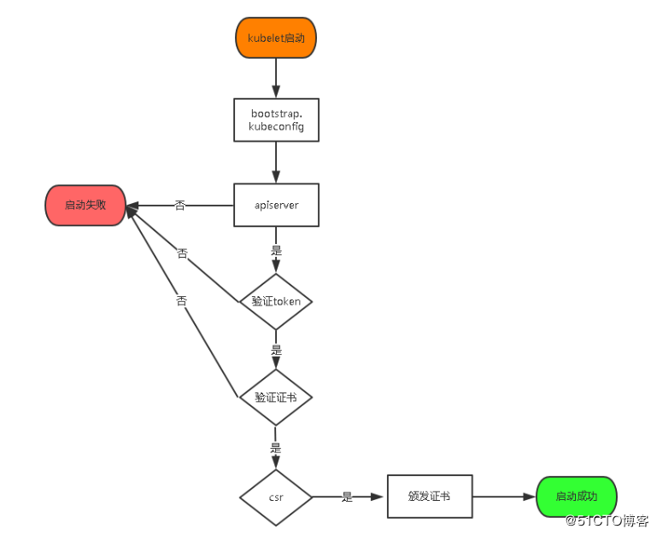

5.1 将kubelet-bootstrap用户绑定到系统集群角色
kubectl create clusterrolebinding kubelet-bootstrap \
--clusterrole=system:node-bootstrapper \
--user=kubelet-bootstrap

5.2 创建kubeconfig文件
在生成kubernetes证书的目录下执行以下命令生成kubeconfig文件：
# 创建kubelet bootstrapping kubeconfig
BOOTSTRAP_TOKEN=674c457d4dcf2eefe4920d7dbb6b0ddc
KUBE_APISERVER="https://192.168.31.63:6443"

# 设置集群参数
kubectl config set-cluster kubernetes \
--certificate-authority=./ca.pem \
--embed-certs=true \
--server=${KUBE_APISERVER} \
--kubeconfig=bootstrap.kubeconfig

# 设置客户端认证参数
kubectl config set-credentials kubelet-bootstrap \
--token=${BOOTSTRAP_TOKEN} \
--kubeconfig=bootstrap.kubeconfig

# 设置上下文参数
kubectl config set-context default \
--cluster=kubernetes \
--user=kubelet-bootstrap \
--kubeconfig=bootstrap.kubeconfig

# 设置默认上下文
kubectl config use-context default --kubeconfig=bootstrap.kubeconfig

#----------------------

# 创建kube-proxy kubeconfig文件

kubectl config set-cluster kubernetes \
--certificate-authority=./ca.pem \
--embed-certs=true \
--server=${KUBE_APISERVER} \
--kubeconfig=kube-proxy.kubeconfig

kubectl config set-credentials kube-proxy \
--client-certificate=./kube-proxy.pem \
--client-key=./kube-proxy-key.pem \
--embed-certs=true \
--kubeconfig=kube-proxy.kubeconfig

kubectl config set-context default \
--cluster=kubernetes \
--user=kube-proxy \
--kubeconfig=kube-proxy.kubeconfig

kubectl config use-context default --kubeconfig=kube-proxy.kubeconfig
# ls
bootstrap.kubeconfig kube-proxy.kubeconfig
将这两个文件拷贝到Node节点/opt/kubernetes/cfg目录下。

5.2 部署kubelet组件
将前面下载的二进制包中的kubelet和kube-proxy拷贝到/opt/kubernetes/bin目录下。
创建kubelet配置文件：
# cat /opt/kubernetes/cfg/kubelet
KUBELET_OPTS="--logtostderr=true \
--v=4 \
--hostname-override=192.168.31.65 \
--kubeconfig=/opt/kubernetes/cfg/kubelet.kubeconfig \
--bootstrap-kubeconfig=/opt/kubernetes/cfg/bootstrap.kubeconfig \
--config=/opt/kubernetes/cfg/kubelet.config \
--cert-dir=/opt/kubernetes/ssl \
--pod-infra-container-image=registry.cn-hangzhou.aliyuncs.com/google-containers/pause-amd64:3.0"
参数说明：
- --hostname-override 在集群中显示的主机名
- --kubeconfig 指定kubeconfig文件位置，会自动生成
- --bootstrap-kubeconfig 指定刚才生成的bootstrap.kubeconfig文件
- --cert-dir 颁发证书存放位置
- --pod-infra-container-image 管理Pod网络的镜像
其中/opt/kubernetes/cfg/kubelet.config配置文件如下：
kind: KubeletConfiguration
apiVersion: kubelet.config.k8s.io/v1beta1
address: 192.168.31.65
port: 10250
readOnlyPort: 10255
cgroupDriver: cgroupfs
clusterDNS: ["10.0.0.2"]
clusterDomain: cluster.local.
failSwapOn: false
authentication:
anonymous:
enabled: true
systemd管理kubelet组件：
# cat /usr/lib/systemd/system/kubelet.service
[Unit]
Description=Kubernetes Kubelet
After=docker.service
Requires=docker.service

[Service]
EnvironmentFile=/opt/kubernetes/cfg/kubelet
ExecStart=/opt/kubernetes/bin/kubelet $KUBELET_OPTS
Restart=on-failure
KillMode=process

[Install]
WantedBy=multi-user.target
启动：
# systemctl daemon-reload
# systemctl enable kubelet
# systemctl restart kubelet
在Master审批Node加入集群：
启动后还没加入到集群中，需要手动允许该节点才可以。
在Master节点查看请求签名的Node：
# kubectl get csr
# kubectl certificate approve XXXXID
# kubectl get node

5.3 部署kube-proxy组件
创建kube-proxy配置文件：
# cat /opt/kubernetes/cfg/kube-proxy
KUBE_PROXY_OPTS="--logtostderr=true \
--v=4 \
--hostname-override=192.168.31.65 \
--cluster-cidr=10.0.0.0/24 \
--kubeconfig=/opt/kubernetes/cfg/kube-proxy.kubeconfig"
systemd管理kube-proxy组件：
# cat /usr/lib/systemd/system/kube-proxy.service
[Unit]
Description=Kubernetes Proxy
After=network.target

[Service]
EnvironmentFile=-/opt/kubernetes/cfg/kube-proxy
ExecStart=/opt/kubernetes/bin/kube-proxy $KUBE_PROXY_OPTS
Restart=on-failure

[Install]
WantedBy=multi-user.target
启动：
# systemctl daemon-reload
# systemctl enable kube-proxy
# systemctl restart kube-proxy
Node2部署方式一样。

6. 查看集群状态
# kubectl get node
NAME STATUS ROLES AGE VERSION
192.168.31.65 Ready <none> 1d v1.12.0
192.168.31.66 Ready <none> 1d v1.12.0
# kubectl get cs
NAME STATUS MESSAGE ERROR
controller-manager Healthy ok
scheduler Healthy ok
etcd-2 Healthy {"health":"true"}
etcd-1 Healthy {"health":"true"}
etcd-0 Healthy {"health":"true"}

7. 运行一个测试示例
创建一个Nginx Web，测试集群是否正常工作：
# kubectl run nginx --image=nginx --replicas=3
# kubectl expose deployment nginx --port=88 --target-port=80 --type=NodePort
查看Pod，Service：
# kubectl get pods
NAME READY STATUS RESTARTS AGE
nginx-64f497f8fd-fjgt2 1/1 Running 3 1d
nginx-64f497f8fd-gmstq 1/1 Running 3 1d
nginx-64f497f8fd-q6wk9 1/1 Running 3 1d
# kubectl get svc
NAME TYPE CLUSTER-IP EXTERNAL-IP PORT(S) AGE
kubernetes ClusterIP 10.0.0.1 <none> 443/TCP 28d
nginx NodePort 10.0.0.175 <none> 88:38696/TCP 28d
访问集群中部署的Nginx，打开浏览器输入：http://192.168.31.66:38696
